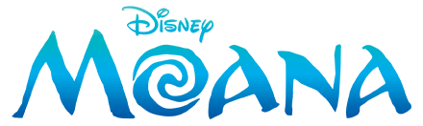

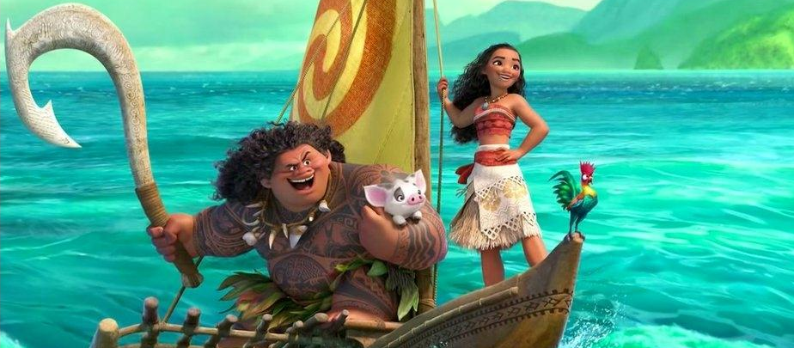
Pua
Hei Hei
Moana
Maui
Moana, Disney’s 56th animated feature, is a computer-animated-musical-fantasy-comedy-adventure film based off of the Māori mythology story of Māui. Moana tells the story of Moana, a powerful, brave, and independent daughter of a chief of a Polynesian tribe. She is chosen by the ocean to reunite a mystical stone with a goddess to save her people from the darkness. Moana sets sail on an adventure in search of a demigod named Māui. They work together and discover their strength through battles with the treacherous ocean and learn the power that friendship, understanding, and trust can accomplish.

The Legend of Māui
Māui was the gifted, clever demigod of Polynesian mythology responsible for fishing up the North Island of Aotearoa, New Zealand. After a miraculous birth and upbringing, Māui won the affection of his supernatural parents, taught useful arts to mankind, snared the sun and tamed fire. But one of his most famous feats was fishing up the North Island.

Despising him, Māui’s four brothers conspired to leave him behind when they went out fishing. Overhearing their plans, Māui secretly made a fishhook from a magical ancestral jawbone. Then one night he crept into his brothers' canoe and hid under the floorboards. It wasn't until the brothers were far out of sight of land and had filled the bottom of their canoe with fish that Māui revealed himself. Then he took out his magic fishhook and threw it over the side of the canoe, chanting powerful incantations as he did so. The hook went deeper and deeper into the sea until Māui felt the hook had touched something. He tugged gently and far below the hook caught fast. It was a huge fish! Together with his brothers, Māui brought the fish to the surface. Māui cautioned his brothers to wait until he had appeased Tangaroa the god of the sea before they cut into the fish. They grew tired of waiting and began to carve out pieces for themselves. These are now the many valleys, mountains, lakes and rocky coastlines of the North Island.

To this day the North Island is known to Māori as Te Ika a Māui or Māui’s fish. Take a look at a map of New Zealand to see the fish’s head in the south and its tail in the north. The South Island is also known as Te Waka a Māui or Māui’s canoe, and Stewart Island or Rakiura is known as Te Punga a Māui or Māui’s anchor stone.

Before Watching the Film
What do you know about Polynesian culture? How do you think it will impact the film?

_____________________________________________________________________________

_____________________________________________________________________________

Have you ever been to a Polynesian island? If yes, what did it look like? If no, what do you think it would look like?

_____________________________________________________________________________

_____________________________________________________________________________

This is Disney’s 56th animated feature. What other Disney animated features have you seen? What did you think about other Disney animations?

_____________________________________________________________________________

_____________________________________________________________________________

What are historical movies? What are fantasy movies? What are musical movies? What are animated movies?

_____________________________________________________________________________

_____________________________________________________________________________

_____________________________________________________________________________

Do you think historical movies are educational? or entertaining? Explain your answer.

_____________________________________________________________________________

_____________________________________________________________________________

How can music influence storytelling? _____________________________________________

_____________________________________________________________________________

_____________________________________________________________________________

During the Film

This film displays parts of the Polynesian culture. Watch the scene for the song “Where You Are”. Make a list of cultural practices and explore some of these concepts in more detail.
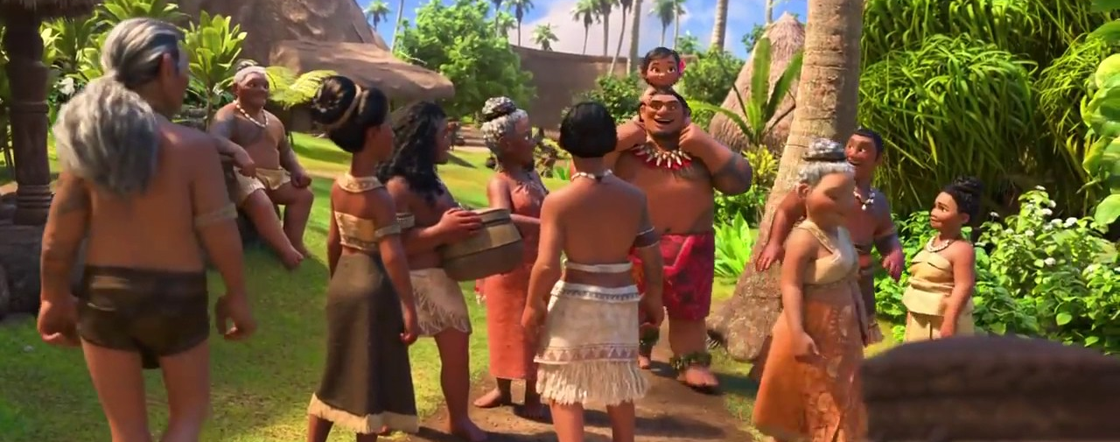

Why is it important to include Polynesian culture in the film?

_____________________________________________________________________________

_____________________________________________________________________________

_____________________________________________________________________________

Early in the film, Moana has a desire to go out into the sea and explore the world, as was the way of her early ancestors. Watch the scene for “We Know the Way”. Discuss what it means to be an explorer. Have explorers impacted your local or cultural history? If so, how? How have explorers impacted world history?

_____________________________________________________________________________

_____________________________________________________________________________

_____________________________________________________________________________

_____________________________________________________________________________

_____________________________________________________________________________

Moana’s Grandmother explains to her that their people have forgotten who they are and stopped traveling. Using your knowledge of geography, why do you think they were travelers to begin with? Why do you think they “forgot?”

_____________________________________________________________________________

_____________________________________________________________________________

_____________________________________________________________________________

_____________________________________________________________________________

Watch the scene where Moana tries to go out beyond the reef. Discuss different types of boats of early explorers. Why are some boats meant for close to the shore and others for further ocean travel?

_____________________________________________________________________________

_____________________________________________________________________________

_____________________________________________________________________________

_____________________________________________________________________________

_____________________________________________________________________________

After Watching the Film

How did the film make you feel? What does it make you think about?

_____________________________________________________________________________

_____________________________________________________________________________

How would different people view this film differently (dependent on gender, age, ethnic background, worldview, etc)?

_____________________________________________________________________________

_____________________________________________________________________________

What comments are the directors trying to make about the culture of the characters in this story?

_____________________________________________________________________________

_____________________________________________________________________________

Which character did you [admire, hate, love, pity] the most? Why?

_____________________________________________________________________________

_____________________________________________________________________________

What part of the story told by the movie was the most powerful? Why?

_____________________________________________________________________________

_____________________________________________________________________________

If you were writing the screenplay for this movie, would you have changed the ending?
Explain your answer.

_____________________________________________________________________________

_____________________________________________________________________________

Enrichment

Think about a story that you have heard that is specific to your culture (i.e. The Legend of Maui for Polynesians, the Loch Ness Monster for Scottish, or the New Jersey Devil for residents of New Jersey), write a brief summary (6-8 sentences minimum) telling the story. Be sure to include cultural specifics (i.e. religion, language, etc.)

_____________________________________________________________________________

_____________________________________________________________________________

_____________________________________________________________________________

_____________________________________________________________________________

_____________________________________________________________________________

_____________________________________________________________________________

_____________________________________________________________________________

_____________________________________________________________________________

_____________________________________________________________________________

_____________________________________________________________________________

_____________________________________________________________________________

_____________________________________________________________________________

_____________________________________________________________________________

_____________________________________________________________________________

_____________________________________________________________________________

_____________________________________________________________________________

_____________________________________________________________________________

“Where You Are”  Lyrics | “We Know the Way”  Lyrics
Moana, make way, make way!  Moana, it's time you knew  The village of Motunui is  All you need  The dancers are practicing  They dance to an ancient song  (Who needs a new song? This old one's all we need)  This tradition is our mission  And Moana, there's so much to do (make way!)  Don't trip on the taro root  That's all you need  We share everything we make (we make)  We joke and we weave our baskets (aha!)  The fishermen come back from the sea  I wanna see  Don't walk away  Moana, stay on the ground now  Our people will need a chief  And there you are  There comes a day  When you're gonna look around  And realize happiness is  Where you are  Consider the coconut (the what?)  Consider its tree  We use each part of the coconut  That's all we need  We make… | Aue, aue  We set a course to find  A brand new island everywhere we roam  Aue, aue  We keep our island in our mind  And when it's time to find home  We know the way  Aue, aue  We are explorers reading every sign  We tell the stories of our elders in a never-ending chain  Aue, aue  Te fenua, te malie  Na heko hakilia  We know the way  