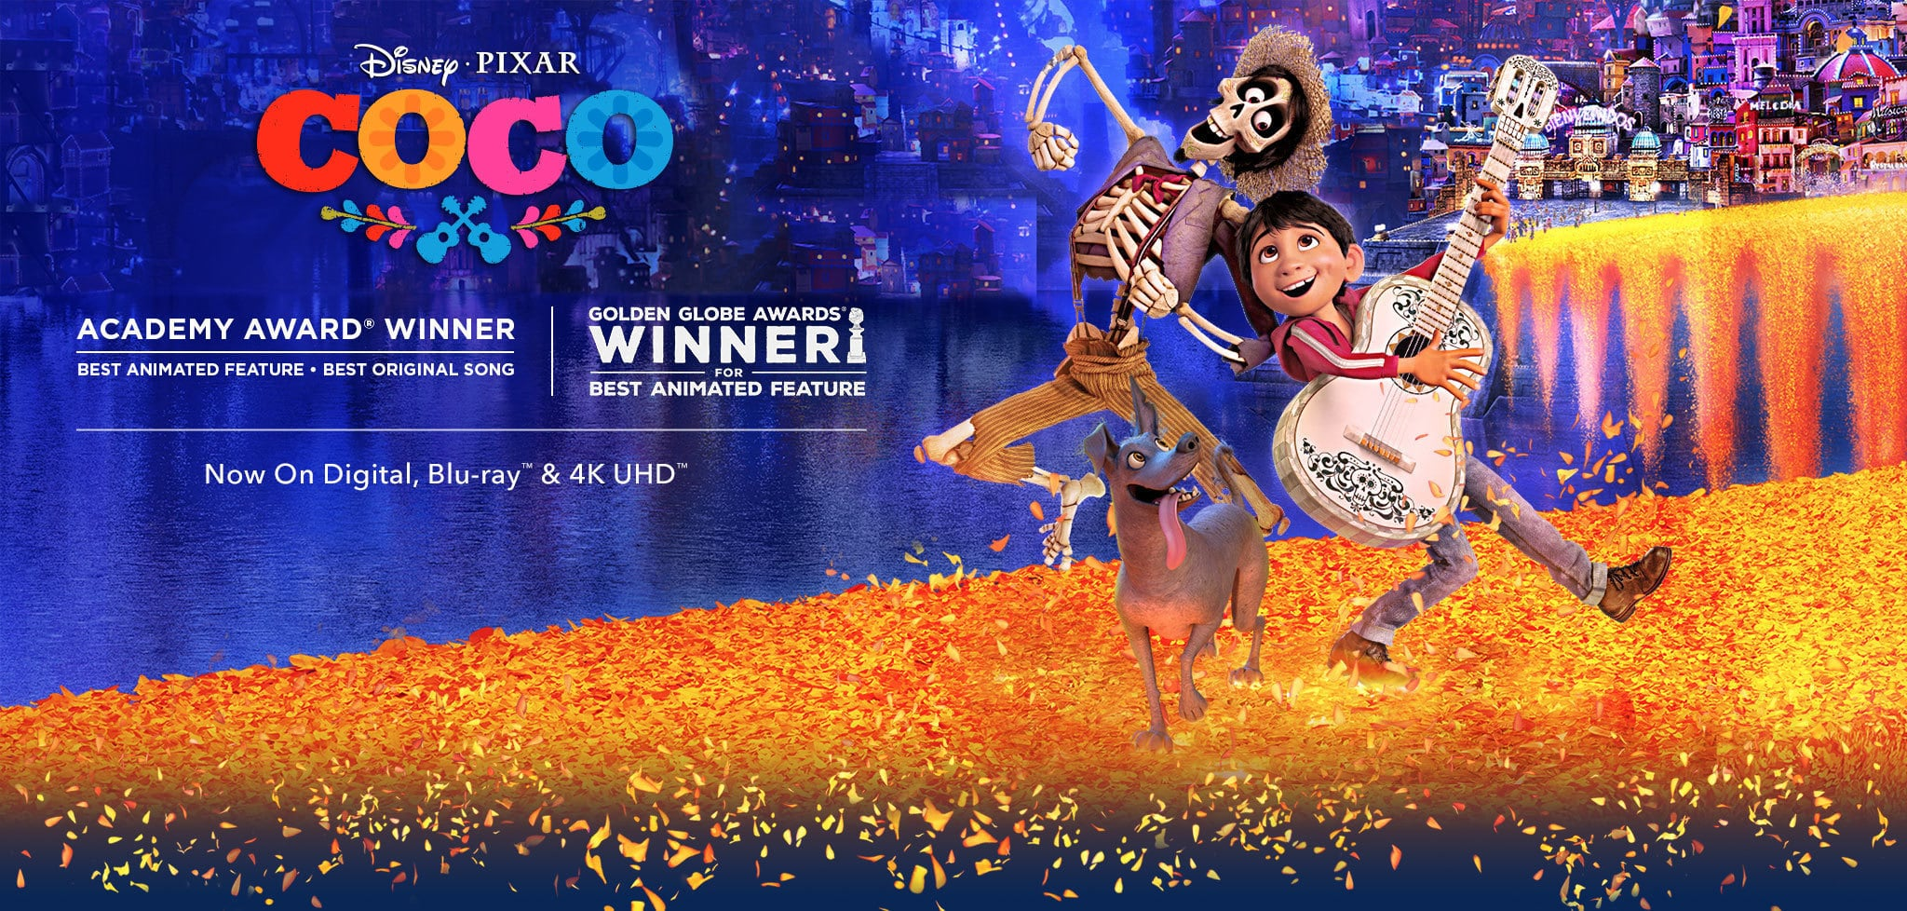
Hector
Dante
Miguel

The new Pixar-Disney movie “Coco” tells the story of a boy, Miguel, who on the Mexican holiday called Día de los muertos (Day of the dead) crosses over from the land of the living into the spirit world. The movie centers on and highlights Mexican traditions of Día de los muertos and culture.
What is Dia de los Muertos?

Dia de los Muertos—the Day of the Dead—is a holiday celebrated on November 1st and November 2 nd . Although marked throughout Latin America, Dia de los Muertos is most strongly associated with Mexico, where the tradition originated.

Dia de los Muertos honors the dead with festivals and lively celebrations, a typically Latin American custom that combines indigenous Aztec ritual with Catholicism, brought to the region by Spanish conquistadores. (Dia de los Muertos is celebrated on All Saints Day and All Souls Day, minor holidays in the Catholic calendar.)

Assured that the dead would be insulted by mourning or sadness, Dia de los Muertos celebrates the lives of the deceased with food, drink, parties, and activities the dead enjoyed in life. Dia de los Muertos recognizes death as a natural part of the human experience, a continuum with birth, childhood, and growing up to become a contributing member of the community. On Dia de los Muertos, the dead are also a part of the community, awakened from their eternal sleep to share celebrations with their loved ones.

The most familiar symbol of Dia de los Muertos may be the calacas and calaveras (skeletons and skulls), which appear everywhere during the holiday: in candied sweets, as parade masks, as dolls. Calacas and calaveras are almost always portrayed as enjoying life, often in fancy clothes and entertaining situations.

- Family members often clean and decorate the graves of loved ones on Dia de los Muertos.

- In addition to celebrations, the dead are honored on Dia de los Muertos with ofrendas—small, personal altars honoring one person. Ofrendas often have flowers, candles, food, drinks, photos, and personal mementos of the person being remembered.

- Dia de los Muertos is actually Dias (plural) de los Muertos—the holiday is spread over two days. November 1 is Dia de los Inocentes, honoring children who have died. Graves are decorated with white orchids and baby's breath. November 2 is Dia de los Muertos, honoring adults, whose graves are decorated with bright orange marigolds.

Term/Part of Speech/ Definition Encyclopedic Entry

- Aztec (Noun): people and culture native to Mexico and Central America.

- Catholicism (Noun): type of Christian religion loyal to the Roman Catholic Church and the leader of that church, the Pope.

- Conquistador (Noun): Spanish explorer or conqueror of Latin America in the 16th century.

- Dia de los Muertos (Noun): (Day of the Dead) holiday honoring deceased family and friends, celebrated on November 1 and November 2 in Mexico and throughout Latin America.

- Holiday (Noun): period of celebration or honor.

- Indigenous (Adjective): characteristic to or of a specific place.

- Latin America (Noun): South America, Central America, the Caribbean, and Mexico.

- Originate (Verb): to begin or start.

- Ritual (Noun): Series of customs or procedures for a ceremony, often religious.

Day of the Dead - Comprehension questions:

What are Calacas and Calaveras?

___________________________________________________________________________________________

___________________________________________________________________________________________

___________________________________________________________________________________________

What two days is Día de los muertos celebrated and why are there two days?

___________________________________________________________________________________________

___________________________________________________________________________________________

___________________________________________________________________________________________

- What is the purpose of Día de los muertos?

___________________________________________________________________________________________

___________________________________________________________________________________________

___________________________________________________________________________________________

What do people believe happens to the souls of deceased family members during Día de los muertos?

___________________________________________________________________________________________

___________________________________________________________________________________________

___________________________________________________________________________________________

What do people do to celebrate Día de los muertos?

___________________________________________________________________________________________

___________________________________________________________________________________________

___________________________________________________________________________________________

___________________________________________________________________________________________

___________________________________________________________________________________________

___________________________________________________________________________________________

During the Film
Directions: While watching Coco list and explain the different Products, Practices, and Perspectives you see in the film.

Products
What cultural items are used in a celebration? These can be tangible or intangible such as clothing, food, music, dances, poems, etc,.
Practices
What is the ritual or pattern of behavior? What are the people DOING? When are they doing it?
Perspectives
The reason WHY they are doing it. What is the history behind this event? What is the purpose of this tradition/event?

After Watching the Film

How did the film make you feel? What does it make you think about?

_____________________________________________________________________________

_____________________________________________________________________________

How would different people view this film differently (dependent on gender, age, ethnic background, worldview, etc)?

_____________________________________________________________________________

_____________________________________________________________________________

What comments are the directors trying to make about the culture of the characters in this story?

_____________________________________________________________________________

_____________________________________________________________________________

Which character did you [admire, hate, love, pity] the most? Why?

_____________________________________________________________________________

_____________________________________________________________________________

What part of the story told by the movie was the most powerful? Why?

_____________________________________________________________________________

_____________________________________________________________________________

If you were writing the screenplay for this movie, would you have changed the ending?
Explain your answer.

_____________________________________________________________________________

_____________________________________________________________________________

Enrichment

Think about a story that you have heard that is specific to your culture (i.e. The Legend of Maui for Polynesians, the Loch Ness Monster for Scottish, or the New Jersey Devil for residents of New Jersey), write a brief summary (6-8 sentences minimum) telling the story. Be sure to include cultural specifics (i.e. religion, language, etc.)

_____________________________________________________________________________

_____________________________________________________________________________

_____________________________________________________________________________

_____________________________________________________________________________

_____________________________________________________________________________

_____________________________________________________________________________

_____________________________________________________________________________

_____________________________________________________________________________

_____________________________________________________________________________

_____________________________________________________________________________

_____________________________________________________________________________

_____________________________________________________________________________

_____________________________________________________________________________

_____________________________________________________________________________

_____________________________________________________________________________

_____________________________________________________________________________

_____________________________________________________________________________

“Where You Are”  Lyrics | “We Know the Way”  Lyrics
Moana, make way, make way!  Moana, it's time you knew  The village of Motunui is  All you need  The dancers are practicing  They dance to an ancient song  (Who needs a new song? This old one's all we need)  This tradition is our mission  And Moana, there's so much to do (make way!)  Don't trip on the taro root  That's all you need  We share everything we make (we make)  We joke and we weave our baskets (aha!)  The fishermen come back from the sea  I wanna see  Don't walk away  Moana, stay on the ground now  Our people will need a chief  And there you are  There comes a day  When you're gonna look around  And realize happiness is  Where you are  Consider the coconut (the what?)  Consider its tree  We use each part of the coconut  That's all we need  We make… | Aue, aue  We set a course to find  A brand new island everywhere we roam  Aue, aue  We keep our island in our mind  And when it's time to find home  We know the way  Aue, aue  We are explorers reading every sign  We tell the stories of our elders in a never-ending chain  Aue, aue  Te fenua, te malie  Na heko hakilia  We know the way  